NAME : SURIYA T ROLL NO : 241501228

EXP.NO: 3

Write a Servlet program that prints "Hello, World!" when accessed through a browser.

AIM

To write a basic Servlet program that demonstrates the use of Java Servlets by printing "Hello, World!" when accessed through a browser

ALGORITHM
1. Input:
• The user makes an HTTP request (usually by entering a URL) through a browser.
2. Servlet Program Flow:
1. Create a Servlet Class: o Define a Java class that extends the HttpServlet class. o Override the doGet() method, which handles HTTP GET requests from the client (browser).
2. Handle HTTP Request: o In the doGet() method: ♣ Get the PrintWriter object to write the response to the browser. ♣ Set the response content type to text/html. 7 ♣ Write the "Hello, World!" message to the response.
3. Compile the Servlet Class: o Compile the Java Servlet file using the javac command to generate a .class file.
4. Deploy the Servlet: o Place the compiled servlet class file in the appropriate directory of the web application (typically in the /WEB-INF/classes folder). o Configure the servlet in the web.xml file of the web application or use annotations.
5. Access the Servlet via Browser: o Start the Apache Tomcat or another servlet container. o Access the servlet by entering the appropriate URL (e.g., http://localhost:8080/your-webapp/hello).

CODE
package com.example;

import java.io.IOException;
import java.io.PrintWriter;
import javax.servlet.ServletException;
import javax.servlet.annotation.WebServlet;
import javax.servlet.http.HttpServlet;
import javax.servlet.http.HttpServletRequest;
import javax.servlet.http.HttpServletResponse;

@WebServlet("/hello")
public class HelloServlet extends HttpServlet {

protected void doGet(HttpServletRequest request, HttpServletResponse response)
throws ServletException, IOException {

response.setContentType("text/html");

PrintWriter out = response.getWriter();
out.println("<h1>Hello, World!</h1>");
}
}
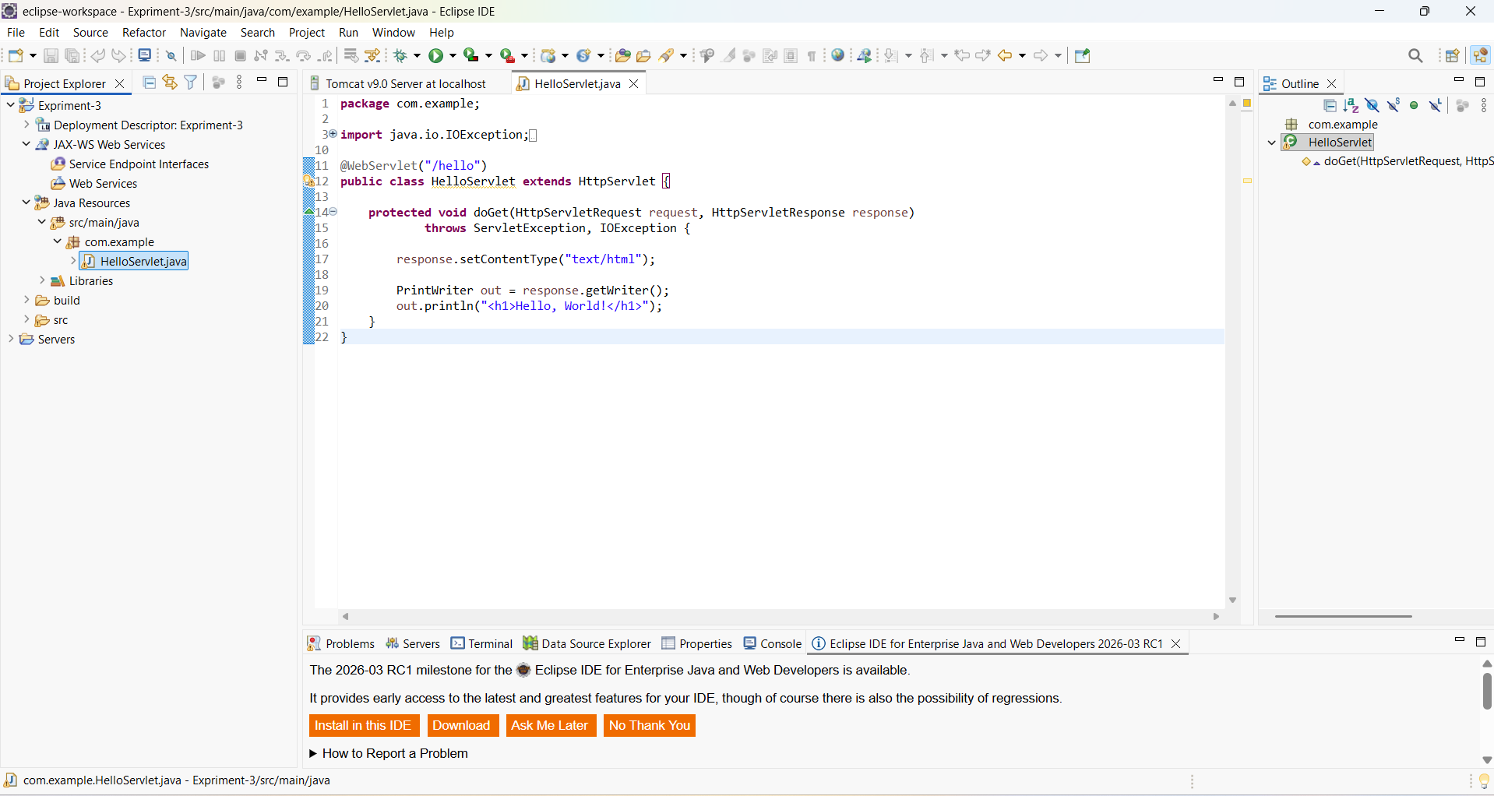

OUTPUT
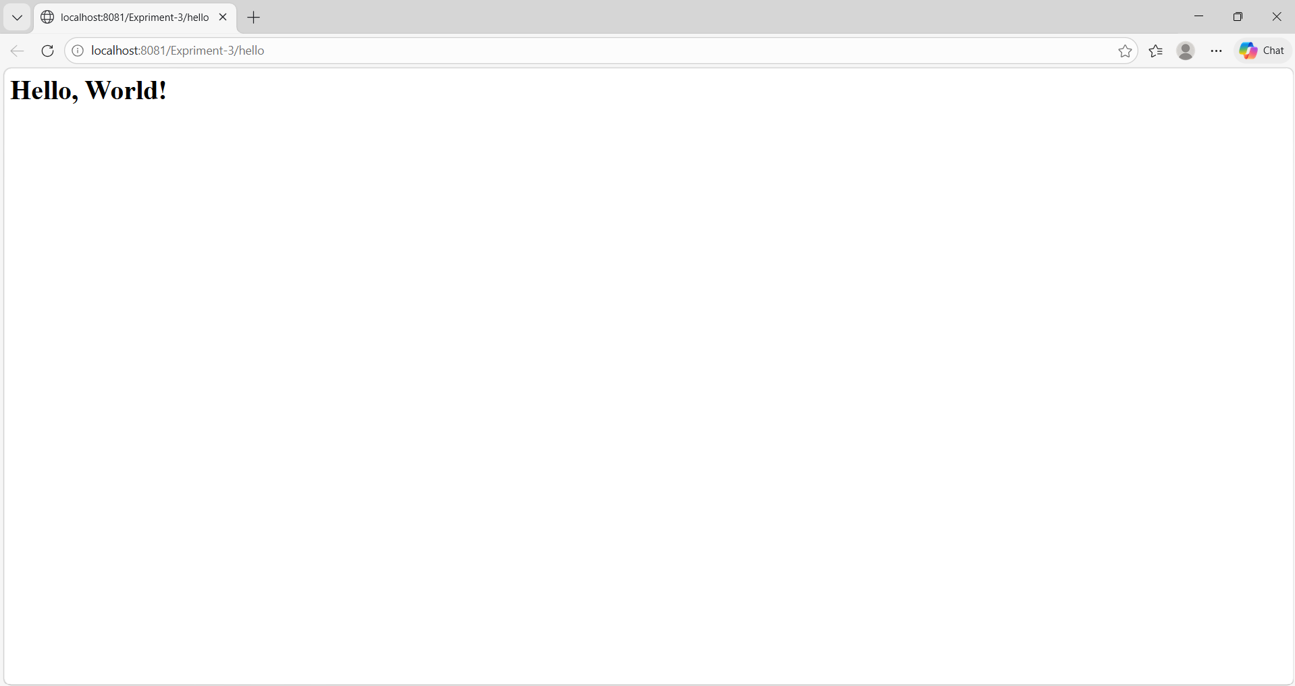

RESULT
The browser will display the message "Hello, World!" returned by the Servlet.

